St Peter’s Church,
Formby

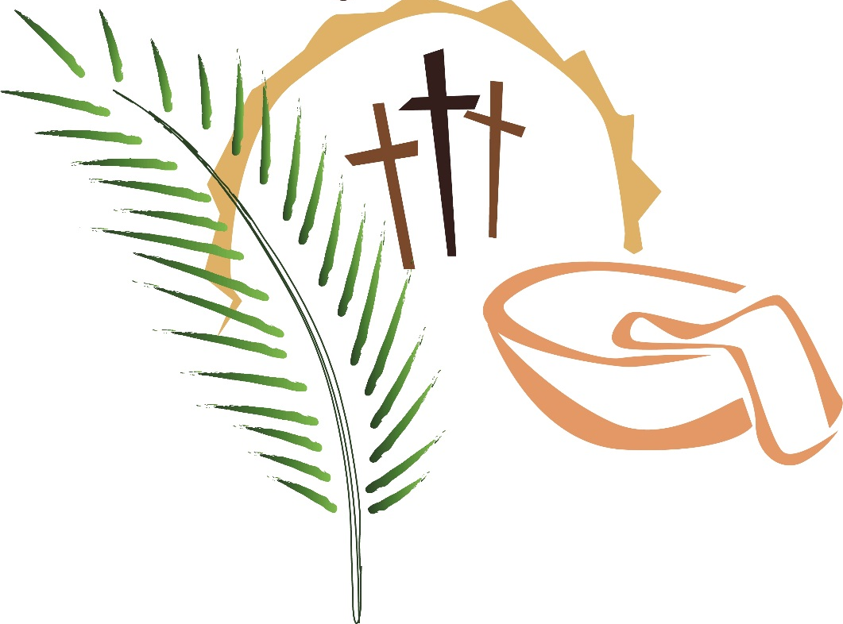

The Eucharist
in
Passiontide

Passiontide is the season when we especially commemorate the events leading up to Christ’s death and resurrection – his coming to Jerusalem, the triumphal entry to the city, the institution of the Eucharist, the washing of the disciples’ feet, the agony of Gethsemane, his crucifixion and burial.

Through participation in the services of this season, we share in Christ’s own journey, and prepare ourselves for the joyful celebration of Easter.

‘Is it nothing to you, all you that pass by?
Behold and see if there be any sorrow
like unto my sorrow’

+++++++++++++++++++++++++++++++++++++

Let the peace of this church surround you as you sit or kneel quietly.
Let the hurry and worry of your life fall away from you. You are God’s child. He loves you and cares for you. He is here with you now – and always.

Lord, thank you……………
for your presence here,
for the opportunity to pray,
for the promise of peace,
for the kindness of people,
for friendship and fellowship,
for all whom I love……….…
and those who love me……
for your love towards me
for the cross of Christ,
and all he suffered and endured for me.
Help me to show my gratitude in this time of worship
and in my daily life. Amen.

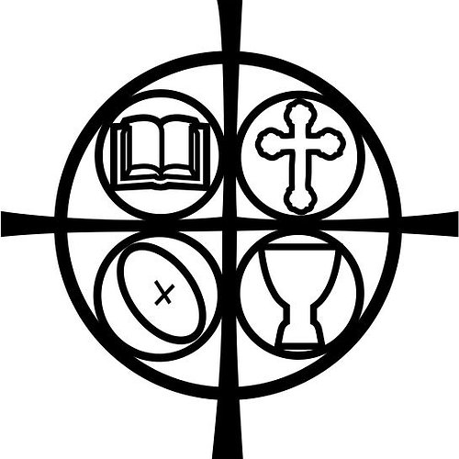
The Gathering

Opening Hymn

The president says

In the name of the Father,
and of the Son,
and of the Holy Spirit.
All: Amen.

The president greets the people

Grace, mercy and peace
from God our Father
and the Lord Jesus Christ
be with you
All: and also with you.

Prayer of Preparation

All:
Almighty God,
to whom all hearts are open,
all desires known,
and from whom no secrets are hidden:
cleanse the thoughts of our hearts
by the inspiration of your Holy Spirit,
that we may perfectly love you,
and worthily magnify your holy name;
through Christ our Lord.
Amen.

Invitation to Confession
God shows his love for us
in that, while we were still sinners, Christ died for us.
Let us then show our love for him
by confessing our sins in penitence and faith.

All:
Lord God, we have sinned against you;
we have done evil in your sight.
We are sorry and repent.
Have mercy on us according to your love.
Wash away our wrongdoing and cleanse us from our sin.
Renew a right spirit within us
and restore us to the joy of your salvation,
through Jesus Christ our Lord. Amen.

The president says

May the God of love
bring you back to himself,
forgive you your sins,
and assure you of his eternal love
in Jesus Christ our Lord. Amen.

Kyrie eleison

Lord, have mercy
All: Lord, have mercy

Christ, have mercy
All: Christ, have mercy

Lord, have mercy
All: Lord, have mercy

The Collect

At the end of the Collect we respond
All: Amen

We sit

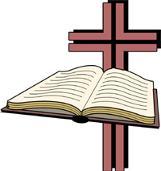
The Liturgy of the Word

The Epistle

At the end the reader says

This is the word of the Lord.
All: Thanks be to God.

Gradual Hymn

We remain standing and face the reader of the Gospel

Gospel Reading

Hear the Gospel of our Lord Jesus Christ according to N.
All: Glory to you, O Lord.

At the end of the Gospel, the reader says

This is the Gospel of the Lord.
All: Praise to you, O Christ.

Sermon

The Creed We stand as the president says

Let us declare our faith in God.

All We believe in God the Father,
from whom every family
in heaven and on earth is named.

We believe in God the Son,
who lives in our hearts through faith,
and fills us with his love.

We believe in God the Holy Spirit,
who strengthens us
with power from on high.

We believe in one God;
Father, Son and Holy Spirit.
Amen.
Prayers of Intercession

The president says

Let us pray to the Father, who loved us so much that he sent his only Son to give us life

These responses are used

Lord, in your mercy
All: hear our prayer.

And at the end

Merciful Father,
All: accept these prayers
for the sake of your Son,
our Saviour Jesus Christ. Amen.

The Liturgy of the Sacrament

We stand

The Peace

The president says
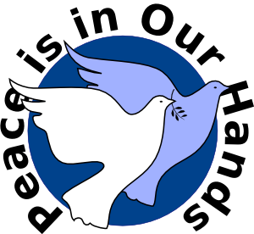
Christ is our peace.
He has reconciled us to God
in one body by the cross.
We meet in his name and share his peace.

The peace of the Lord be always with you
All: and also with you.

A minister says
Let us offer one another a sign of peace.

All may exchange a sign of peace.
Offertory Hymn

Preparation of the Table

Taking of the Bread and Wine

The gifts of the people are gathered and presented.
The altar is prepared and bread and wine are placed upon it.

Jesus, true vine and bread of life,
ever giving yourself that the world might live,
let us share your death and passion:
make us perfect in your love. Amen.
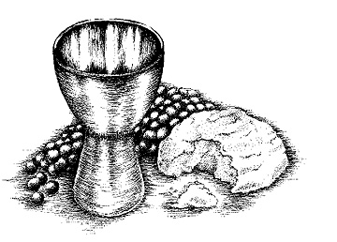

The president says

The Lord is here.
All: His Spirit is with us.

Lift up your hearts.
All: We lift them to the Lord.

Let us give thanks to the Lord our God.
All: It is right to give thanks and praise.

We kneel or sit for the prayer of thanksgiving.

Father, we give you thanks and praise
through your beloved Son Jesus Christ, your living Word,
through whom you have created all things;
who was sent by you in your great goodness to be our Saviour.

By the power of the Holy Spirit he took flesh;
as your Son, born of the blessed Virgin,
he lived on earth and went about among us;
he opened wide his arms for us on the cross;
he put an end to death by dying for us;
and revealed the resurrection by rising to new life;
so he fulfilled your will and won for you a holy people.

And now we give you thanks
because, for our salvation,
he was obedient even to death on the cross.
The tree of shame was made the tree of glory;
and where life was lost, there life has been restored

Therefore with angels and archangels,
and with all the company of heaven,
we proclaim your great and glorious name,
for ever praising you and saying:

All: Holy, holy, holy Lord,
God of power and might,
heaven and earth are full of your glory.
Hosanna in the highest.

Blessed is he who comes in the name of the Lord.
Hosanna in the highest.

Lord, you are holy indeed, the source of all holiness;
grant that by the power of your Holy Spirit,
and according to your holy will,
these gifts of bread and wine
may be to us the body and blood of our Lord Jesus Christ;

who, in the same night that he was betrayed,
took bread and gave you thanks;
he broke it and gave it to his disciples, saying:
Take, eat; this is my body which is given for you;
do this in remembrance of me.

In the same way, after supper
he took the cup and gave you thanks;
he gave it to them, saying:
Drink this, all of you;
this is my blood of the new covenant,
which is shed for you and for many for the forgiveness of sins.
Do this, as often as you drink it,
in remembrance of me.

Great is the mystery of faith:
All: Dying you destroyed our death,
rising you restored our life:
Lord Jesus, come in glory.

And so, Father, calling to mind his death on the cross,
his perfect sacrifice made once for the sins of the whole world;
rejoicing in his mighty resurrection and glorious ascension,
and looking for his coming in glory,
we celebrate this memorial of our redemption.
As we offer you this our sacrifice of praise and thanksgiving,
we bring before you this bread and this cup
and we thank you for counting us worthy
to stand in your presence and serve you.

Send the Holy Spirit on your people
and gather into one in your kingdom
all who share this one bread and one cup,
so that we, in the company of St Peter and all the saints,
may praise and glorify you for ever,
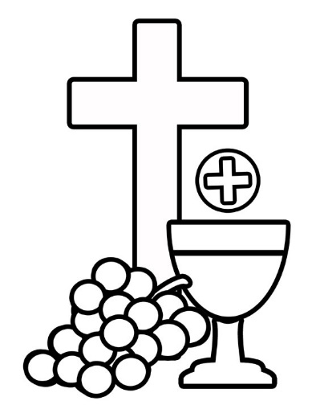
through Jesus Christ our Lord;

by whom, and with whom, and in whom,
in the unity of the Holy Spirit,
all honour and glory be yours, almighty Father,
for ever and ever.
All: Amen.

The Lord’s Prayer

Let us pray with confidence as our Saviour has taught us
Our Father, who art in heaven,
hallowed be thy name;
thy kingdom come;
thy will be done;
on earth as it is in heaven.
Give us this day our daily bread.
And forgive us our trespasses,
as we forgive those who trespass against us.
And lead us not into temptation;
but deliver us from evil.
For thine is the kingdom,
the power and the glory,
for ever and ever.
Amen.

Breaking of the Bread

The president breaks the consecrated bread.

Every time we eat this bread and drink this cup,
All: we proclaim the Lord's death until he comes.

The Agnus Dei is said
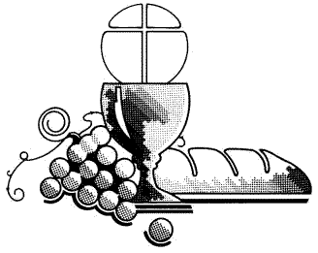
Lamb of God,
you take away the sin of the world,
have mercy on us.

Lamb of God,
you take away the sin of the world,
have mercy on us.

Lamb of God,
you take away the sin of the world,
grant us peace.

Giving of Communion

The president says

Draw near with faith.
Receive the body of our Lord Jesus Christ
which he gave for you,
and his blood which he shed for you.
Eat and drink
in remembrance that he died and lives for you,
and feed on him in your hearts
by faith with thanksgiving.

Communicant members of all Christian Churches are welcome to receive communion. Those who do not wish to receive communion are invited to the altar rail for a blessing and are asked to keep their hands at their side.

We remain seated for the communion hymn.

Prayers after Communion

The Post Communion is said.

Remain kneeling or sitting for the prayers.

All: Faithful God,
may we who share in this sacrament
glory in the cross of our Lord Jesus Christ,
our salvation, life and hope,
who reigns as Lord now and for ever. Amen.

The Dismissal

Post Communion Hymn

Blessing

The president says

The Lord be with you
All: And also with you.

Christ draw you to himself and grant that you find in his cross
a sure ground for faith, a firm support for hope,
and the assurance of sins forgiven: and the blessing of God almighty,
the Father, the Son, and the Holy Spirit,
be with you, and all that you love and care for,
this day and always. Amen.

A minister says

Go in peace to love and serve the Lord.
All: In the name of Christ. Amen.

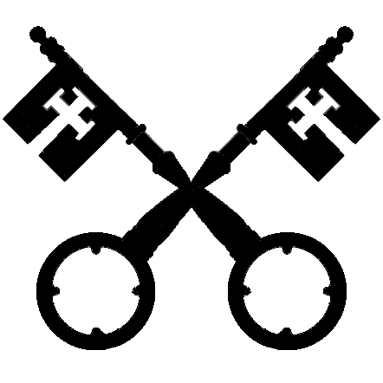
++++++++++++++++++++++++++++++++++++++++++++++

++++++++++++++++++++++++++++++++++++++++++++++

Copyright acknowledgement (where not already indicated above);
Some material included in this service is copyright: © The Archbishops’ Council 2000

