The Ancient Chapelry of Formby

St Peter, Apostle & Martyr

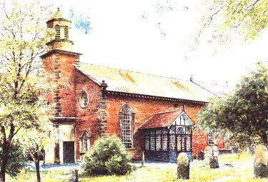

The Eucharist
All Saints to Advent

¶ The Gathering

We stand for the hymn

The president says
In the name of the Father,
and of the Son,
and of the Holy Spirit.
All Amen.

The Greeting

The president greets the people
The Lord be with you
All and also with you.

Prayers of Penitence

A minister invites the people to confess their sins

Christ calls us to share the heavenly banquet of his love
with all the saints in earth and heaven.
Knowing our unworthiness and sin,
let us ask from him both mercy and forgiveness.

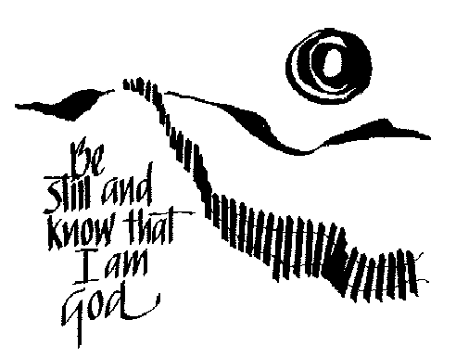

All Lord God,
we have sinned against you
we have done evil in your sight.
We are sorry and repent.
Have mercy on us according to your love.
Wash away our wrongdoing and cleanse us
from our sin.
Renew a right spirit within us
and restore us to the joy of your salvation,
through Jesus Christ our Lord.
Amen.

The president says
Almighty God,
who forgives all who truly repent,
have mercy upon you,
pardon and deliver you from all your sins,
confirm and strengthen you in all goodness,
and keep you in life eternal;
through Jesus Christ our Lord.
All Amen.

Kyrie eleison

Cantors Lord, have mercy.
All Lord, have mercy.

Cantors 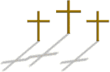Christ, have mercy.
All Christ, have mercy.

Cantors Lord, have mercy.
All Lord, have mercy.

Gloria in Excelsis

All Glory to God in the highest,
and peace to his people on earth.
Lord God, heavenly King,
almighty God and Father,
we worship you, we give you thanks,
we praise you for your glory.
Lord Jesus Christ, only Son of the Father,
Lord God, Lamb of God,
you take away the sin of the world:
have mercy on us;
you are seated at the right hand of the Father:
receive our prayer.
For you alone are the Holy One,
you alone are the Lord,
you alone are the Most High, Jesus Christ,
with the Holy Spirit,
in the glory of God the Father.
Amen.

The Collect
The president says
Let us pray.

At the end of the Collect we respond
All Amen.

We sit

¶ The Liturgy of the Word
Readings
Either one or two readings from Scripture precede the Gospel reading


At the end the reader says
This is the word of the Lord.
All Thanks be to God.

We stand for the hymn

We remain standing and face the reader of the Gospel

Gospel Reading
An acclamation heralds the Gospel reading

All Alleluia, Alleluia.

The Choir will sing the Gospel Acclamation verse

All Alleluia.

When the Gospel is announced the reader says
Hear the Gospel of our Lord Jesus Christ according to N.
All Glory to you, O Lord.

At the end the reader says
This is the Gospel of the Lord.
All Praise to you, O Christ.

Sermon
We sit

We stand
The president says
Let us declare our faith in God, Father, Son and Holy Spirit.
The Creed
All We believe in one God,
the Father, the Almighty,
maker of heaven and earth,
of all that is,
seen and unseen.
We believe in one Lord, Jesus Christ,
the only Son of God,
eternally begotten of the Father,
God from God, Light from Light,
true God from true God,
begotten, not made,
of one Being with the Father;
through him all things were made.
For us and for our salvation
he came down from heaven,
was incarnate from the Holy Spirit and the Virgin Mary
and was made man.
For our sake he was crucified under Pontius Pilate;
he suffered death and was buried.
On the third day he rose again
in accordance with the Scriptures;
he ascended into heaven
and is seated at the right hand of the Father.
He will come again in glory
to judge the living and the dead,
and his kingdom will have no end.

We believe in the Holy Spirit,
the Lord, the giver of life,
who proceeds from the Father and the Son,
who with the Father and the Son
is worshipped and glorified,
who has spoken through the prophets.
We believe in one holy catholic and apostolic Church.
We acknowledge one baptism
for the forgiveness of sins.
We look for the resurrection of the dead,
and the life of the world to come.
Amen.

Prayers of Intercession
The president says
In the power of the Spirit and in union with Christ,
let us pray to the Father.

We kneel or sit for the intercessions

These responses are used unless otherwise announced

Lord, in your mercy
All hear our prayer.

And at the end

Merciful Father,
All accept these prayers
for the sake of your Son,
our Saviour Jesus Christ.
Amen.

¶ The Liturgy of the Sacrament

We stand
The Peace
The president introduces the Peace
To crown all things there must be love,
to bind altogether and complete the whole.
Let the peace of Christ rule in our hearts.

The peace of the Lord be always with you
All and also with you.

A minister says
Let us offer one another a sign of peace.

All may exchange a sign of peace
Preparation of the Altar
Taking of the Bread and Wine

We remain standing for the hymn

The gifts of the people are gathered and presented.
The altar is prepared and bread and wine are placed upon it.

The president takes the bread and wine and says
Blessed are you, Lord God of all creation:
through your goodness we have this bread to set before you,
which earth has given and human hands have made.
It will become for us the bread of life.
All Blessed be God for ever.

Blessed are you, Lord God of all creation:
through your goodness we have this wine to set before you,
fruit of the vine and work of human hands.
It will become for us the cup of salvation.
All Blessed be God for ever.

Eucharistic Prayer B

The president says
The Lord be with you
All and also with you.

Lift up your hearts.
All We lift them to the Lord.

Let us give thanks to the Lord our God.
All It is right to give thanks and praise.

We kneel or sit for the prayer of thanksgiving
Father, we give you thanks and praise
through your beloved Son Jesus Christ, your living Word,
through whom you have created all things;
who was sent by you in your great goodness to be our Saviour.
By the power of the Holy Spirit he took flesh;
as your Son, born of the blessed Virgin,
he lived on earth and went about among us;
he opened wide his arms for us on the cross;
he put an end to death by dying for us;
and revealed the resurrection by rising to new life;
so he fulfilled your will and won for you a holy people.
And now we give you thanks
that he is the King of glory,
who overcomes the sting of death
and opens the kingdom of heaven to all believers.
He is seated at your right hand in glory
and we believe that he will come to be our judge.

Therefore with angels and archangels,
and with all the company of heaven,
we proclaim your great and glorious name,
for ever praising you and saying:

All Holy, holy, holy Lord,
God of power and might,
heaven and earth are full of your glory.
Hosanna in the highest.
Blessed is he who comes in the name of the Lord.
Hosanna in the highest.

Lord, you are holy indeed, the source of all holiness;
grant that by the power of your Holy Spirit,
and according to your holy will,
these gifts of bread and wine
may be to us the body and blood of our Lord Jesus Christ;
who, in the same night that he was betrayed,
took bread and gave you thanks;
he broke it and gave it to his disciples, saying:
Take, eat; this is my body which is given for you;
do this in remembrance of me.
In the same way, after supper
he took the cup and gave you thanks;
he gave it to them, saying:
Drink this, all of you;
this is my blood of the new covenant,
which is shed for you and for many for the forgiveness of sins.
Do this, as often as you drink it,
in remembrance of me.
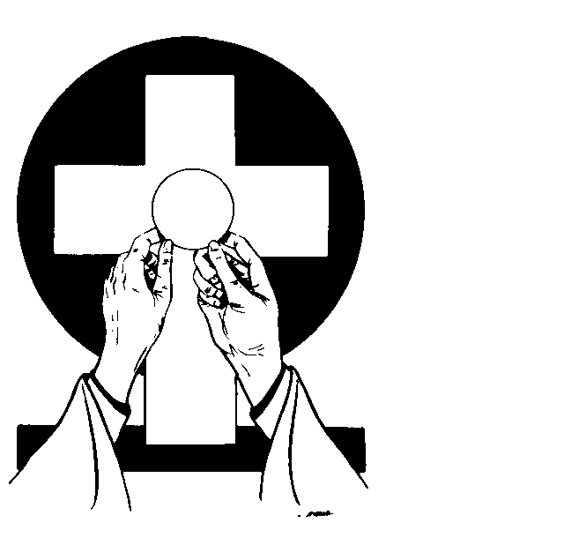
Christ is the bread of life:
All When we eat this bread and drink this cup,
we proclaim your death, Lord Jesus,
until you come in glory.

And so, Father, calling to mind his death on the cross,
his perfect sacrifice made once for the sins of the whole world;
rejoicing in his mighty resurrection and glorious ascension,
and looking for his coming in glory,
we celebrate this memorial of our redemption.
As we offer you this our sacrifice of praise and thanksgiving,
we bring before you this bread and this cup
and we thank you for counting us worthy
to stand in your presence and serve you.
Send the Holy Spirit on your people
and gather into one in your kingdom
all who share this one bread and one cup,
so that we, in the company of St Peter and all the saints,
may praise and glorify you for ever,
through Jesus Christ our Lord;
by whom, and with whom, and in whom,
in the unity of the Holy Spirit,
all honour and glory be yours, almighty Father,
for ever and ever.
All Amen.
The Lord’s Prayer

The president says

Let us pray for the coming of God’s Kingdom in the words our Saviour taught us.

All Our Father, who art in heaven,
hallowed be thy name;
thy kingdom come;
thy will be done;
on earth as it is in heaven.
Give us this day our daily bread.
And forgive us our trespasses,
as we forgive those who trespass against us.
And lead us not into temptation;
but deliver us from evil.
For thine is the kingdom,
the power and the glory,
for ever and ever.
Amen.

Breaking of the Bread

The president breaks the consecrated bread

We break this bread
to share in the body of Christ.

All Though we are many, we are one body,
because we all share in one bread.

The Agnus Dei is said as the bread is broken

All Lamb of God,
you take away the sin of the world,
have mercy on us.
Lamb of God,
you take away the sin of the world,
have mercy on us.
Lamb of God,
you take away the sin of the world,
grant us peace.

Giving of Communion

The president says the invitation to communion

Jesus is the Lamb of God
who takes away the sin of the world.
Blessed are those who are called to his supper.

All Lord, I am not worthy to receive you,
but only say the word, and I shall be healed.

The president and people receive communion

All communicant Christians are welcome to receive communion. Those who do not wish to receive communion are invited to come to the altar rail for a blessing and are asked to make their wish clear by keeping their hands at their side

Authorized words of distribution are used
Communicant Amen.

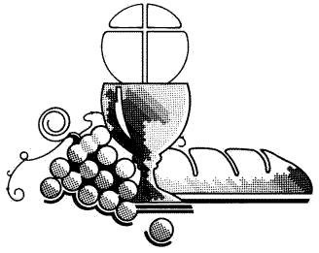

During the distribution the Choir will sing from the Formby Chapel

We remain seated for the hymn during communion

Following the distribution the Choir will sing from the Sanctuary crossing

Prayer after Communion

Silence is kept

The president says
Let us pray

We stand

All Almighty God,
we thank you for feeding us
with the body and blood of your Son Jesus Christ.
Through him we offer you our souls and bodies
to be a living sacrifice.
Send us out
in the power of your Spirit
to live and work
to your praise and glory.
Amen.

¶ The Dismissal

The president may make announcements before introducing the hymn

We stand for the hymn

Blessing
We remain standing

The president says
The Lord be with you
All and also with you.

Christ our King make you faithful and strong to do his will,
that you may reign with him in glory;
and the blessing of God almighty,
the Father, the Son, and the Holy Spirit,
be upon you and remain with you always.
All Amen.

A minister says
Go in the peace of Christ.
All Thanks be to God.

The ministers and people depart

